I Am A Great American

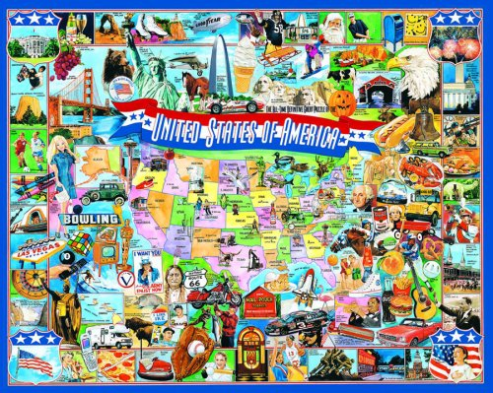
“I like to see a man proud of the place in which he lives. I like to see a man live so that his place will be proud of him. “
~Abraham Lincoln

Name:

Teacher:
What is a “Great American”?

A Great American is someone who knows:

What the Statue of Liberty’s Creed is
The Pledge of Allegiance
How to sing the Star-Spangled Banner
The Preamble to the Constitution
All the states and capitals locations
All the presidents of the United States in order
How to fold the flag and care for it

How can I become a Great American?
- Starting with the bronze level, work on learning the different tasks above!

Why do I want to be a “Great American?”
- You are a proud American!
- You get to lead the Pledge of Allegiance and Prairie Trail Pledge during the morning announcements
- Attend a special Great American graduation
- Take a field trip just for Great American graduates

I want to do this! How do I start?
- As soon as you finish learning a task, take the quiz with a tester on Great American days.
- Get help! Ask what words mean or look up additional information.
- Use the study strategies to help you learn the tasks!
- Practice, practice, practice! Make sure that you know your task very well before you take your quiz.

Start date for program: Tuesday, September 6, 2016
End date for program: Friday, May 5, 2017

You have to be done with your tasks by May 5th!

Level | Tasks | Recommended Tasks | Award
Bronze | Choose any 3 of the 8 tasks to memorize | Pledge of Allegiance, Flag Folding, and Flag Facts | Great American Pencil
Silver | Choose any 5 of the 8 tasks to memorize | Pledge of Allegiance, Flag Folding, Flag Facts, Statue of Liberty Creed, and Preamble | You get to lead the Pledge of Allegiance and the Prairie Trail Pledge during the morning announcements and attend a Great American breakfast
Gold | Memorize all 8 tasks | All 8: Pledge of Allegiance, Flag Folding, Flag Facts, Statue of Liberty Creed, Preamble, States and Capital, Presidents, and Star Spangled Banner | You get to participate in the Great American assembly, get a free Great American t-shirt, and a free field trip

- Every time you finish a level, you will move to the next level. You will receive the prize for that level after you complete that level.
- If you memorize The Gettysburg Address by Abraham Lincoln, you will get a special recognition and award at graduation. You can also substitute The Gettysburg Address as one of the tasks, but you will not receive the special award unless you do all 9 tasks.
- Once you have completed the gold level, you will have opportunities to be a volunteer in and outside of school!

1. The Statue of Liberty Creed

Give me your tired, your poor,
Your huddled masses yearning to breathe free
The wretched refuse of your teeming shore,
Send these, the homeless, tempest tossed to me
I lift my lamp beside the golden door

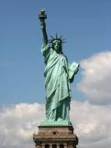

Did You Know?
Standing at the entrance to New York Harbor, the statue was a gift of friendship from the people of France to the United States to celebrate the 100th anniversary of American Independence. It was made in Paris by the French sculptor Frederic-Auguste Bartholdi, with the help on the metalwork from Gustave Eiffel (he made the Eiffel Tower). It has welcomed millions of immigrants to the United States of America since it was inaugurated in 1886. The creed is on the base of the statue written Emma Lazarus in 1883.

_____Completed! Date: ________

2. Pledge of Allegiance

I pledge allegiance to the Flag
Of the United States of America
And to the republic for which it stands
One nation, under God, indivisible
With liberty and justice for all

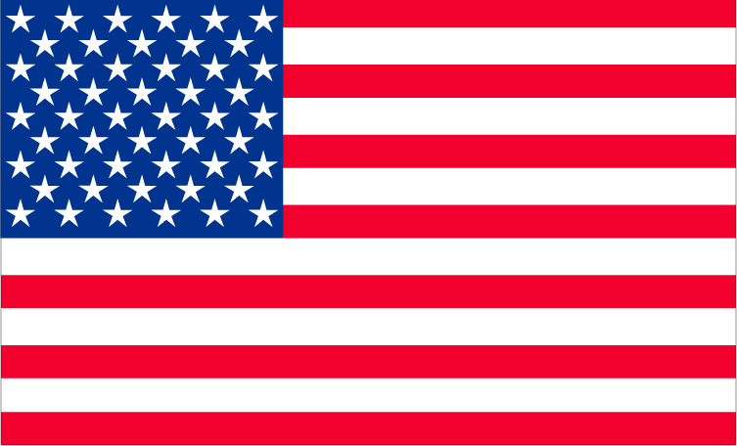

Did you know?
The pledge was first written in 1892 by Francis Bellamy and became our national pledge in 1942. This is an oath taken to promise to be faithful to the United States. It has been changed four times since it was first written. Here is the original pledge:

1892: "I pledge allegiance to my flag and the republic for which it stands: one nation indivisible with liberty and justice for all."

_____Completed! Date: _________

3. The Preamble of the United States Constitution

We, the people of the United States,
In order to form a more perfect union
Establish justice, insure domestic tranquility,
Provide for the common defense,
Promote the general welfare, and
Secure the blessings of liberty
To ourselves and our posterity
Do ordain and establish this Constitution
For the United States of America

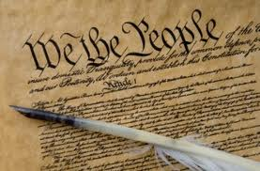

Did you know?
On September 17, 1787 the constitution became the law of the land. The beginning of the constitution is called the preamble and tells that as a country, we will work together to make sure everyone is free, live peacefully, and have rights. James Madison, our fourth President, wrote most of the constitution. In addition, the preamble is the only part of the constitution that can never be changed or amended!

_____Completed! Date: _________

4. The Star Spangled Banner

Oh say can you see by the dawn’s early light
What so proudly we hail’d at the twilight’s last gleaming?
Whose broad stripes and bright stars through the perilous fight
O’er the ramparts we watched were so gallantly streaming?

And the rockets’ red glare, the bombs bursting in air,
Gave proof through the night that our flag was still there.
Oh say does that Star-Spangled Banner yet wave
O’er the land of the free and the home of the brave?

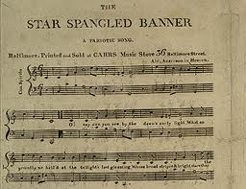

Did you know?
Francis Scott Key wrote the song as a poem in 1814 after he watched a battle during the War of 1812. The poem was added to the music of a British song called “The Anacreontic Song”. The song soon became popular in America and became our national song in 1931.

_____Completed! Date: _________

5. States and Capitals

The next two pages contain a map with all the states and their capitals. One map is left blank so you can practice.

Please learn that you say the city (the capital) first and then the state! For example, Springfield, Illinois not Illinois, Springfield!

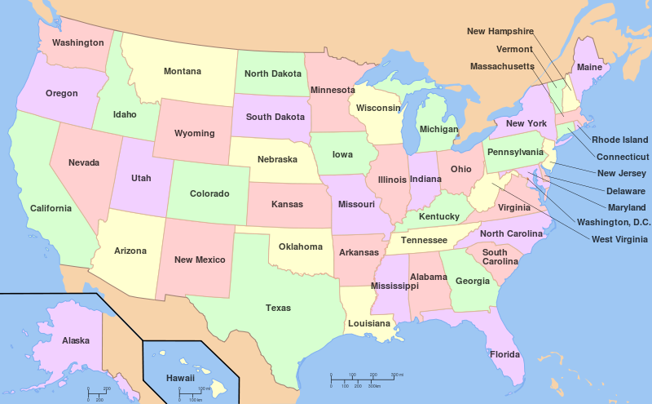

Did you know?
- Arizona has the most telescopes in the world
- A 3,500 year old tree named General Sherman is located in California
- The largest city is New York City in New York
- Chicago, Illinois has one of the largest skyscrapers in the U.S.
- The first state was Delaware in 1787 and the last states were Alaska and Hawaii in 1959.

_____Completed! Date: _________

5. States and Capitals (continued)

State | Capital
Alabama | Montgomery
Alaska | Juneau
Arizona | Phoenix
Arkansas | Little Rock
California | Sacramento
Colorado | Denver
Connecticut | Hartford
Delaware | Dover
Florida | Tallahassee
Georgia | Atlanta
Hawaii | Honolulu
Idaho | Boise
Illinois | Springfield
Indiana | Indianapolis
Iowa | Des Moines
Kansas | Topeka
Kentucky | Frankfort
Louisiana | Baton Rouge
Maine | Augusta
Maryland | Annapolis
Massachusetts | Boston
Michigan | Lansing
Minnesota | St. Paul
Mississippi | Jackson
Missouri | Jefferson City
Montana | Helena
Nebraska | Lincoln
Nevada | Carson City
New Hampshire | Concord
New Jersey | Trenton
New Mexico | Santa Fe

New York | Albany
North Carolina | Raleigh
North Dakota | Bismarck
Ohio | Columbus
Oklahoma | Oklahoma City
Oregon | Salem
Pennsylvania | Harrisburg
Rhode Island | Providence
South Carolina | Columbia
South Dakota | Pierre
Tennessee | Nashville
Texas | Austin
Utah | Salt Lake City
Vermont | Montpelier
Virginia | Richmond
Washington | Olympia
West Virginia | Charleston
Wisconsin | Madison

Wyoming | Cheyenne

6. Presidents of the United States

- George Washington
- John Adams
- Thomas Jefferson
- James Madison
- James Monroe
- John Quincy Adams

- Andrew Jackson
- Martin Van Buren
- William Henry Harrison
- John Tyler
- James Polk
- Zachary Taylor

- Millard Fillmore
- Franklin Pierce
- James Buchanan
- Abraham Lincoln
- Andrew Johnson
- Ulysses S. Grant

- Rutherford B. Hayes
- James A. Garfield
- Chester A. Arthur
- Grover Cleveland
- Benjamin Harrison
- Grover Cleveland

- William McKinley
- Theodore Roosevelt
- William H. Taft
- Woodrow Wilson
- Warren Harding
- Calvin Coolidge

- Herbert Hoover
- Franklin D. Roosevelt
- Harry S. Truman
- Dwight D. Eisenhower
- John F. Kennedy
- Lyndon B. Johnson

- Richard Nixon
- Gerald Ford
- James Carter
- Ronald Reagan

- George H. Bush
- William Clinton
- George W. Bush
- Barack Obama

Did you know?
To become president of the US, you need to be an American citizen born here in the United States. You also need to be at least 35 years old and have lived in the country for 14 years. That is it!
_____Completed! Date: _________

7. The Gettysburg Address (optional)

Four score and seven years ago, our Fathers brought forth on this continent, a new nation, conceived in liberty, and dedicated to the proposition that all men are created equal.

Now we are engaged in a great civil war testing whether that nation, or any nation, so conceived and so dedicated can long endure.

We are met on a great battlefield of that war. We have come to dedicate a portion of that field, as a final resting place for those who here gave their lives that that nation might live.

It is altogether fitting and proper that we should this.

But in a larger sense we cannot dedicate- we cannot consecrate- we cannot hallow this ground. The brave men, living and dead, who struggled here, have consecrated it far above our poor power to add or detract.

The world will little note nor long remember what we say here, but it can never forget what they did here. It is for us, the living, rather, to be dedicated here to the unfinished work, which they who fought here have thus far so nobly advanced.

It is rather for us to be here dedicated to the great task remaining before us- that from these honored dead we take increased devotion to that cause for which they have the last full measure of devotion that we here highly resolve that these dead shall not have died in vain- that this nation, under God shall have a new birth of freedom, and that government of the people, by the people, for the people, shall not perish from the earth.
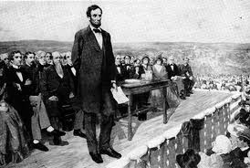
Did you know?
The Gettysburg Address was given on November 19, 1863 by Abraham Lincoln to honor the soldiers who died in a battle in Gettysburg, Pennsylvania. It was only a two minute long speech. The actual wording may be different from what actually said!

_____Completed! Date: _________

8./9. Flags Facts and Folding

- The American flag is displayed from sunrise to sunset unless there is a light shining on it.
- The flag can be found in/near every school and where people vote.
- The flag is burned when it has “served it’s purpose” or no longer useful.
- The original flag had stars in a circle to show every colony was equal.
- There are 13 stripes on the flag to represent the 13 colonies.
- There are 50 stars to represent the 50 states- one star per state.
- Red represents bravery.
- White represents liberty.
- Blue represents justice.
- If the American flag is with other flags, it has to be the highest and the furthest out.
- When looking at the flag while hanging, the blue stars and background should be on the left.
- If you are not in uniform, you place your right hand over your heart.
- If you are in uniform, you salute the flag.
- If a president dies, the flag may be held at half-mast for 30 days.
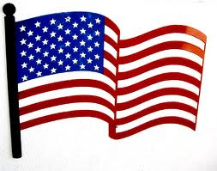

Did you know?
The first flag was made in 1777. Our current flag was made in 1960 because we added two more states into the country. Nicknames for the flag include “Union Jack”, “Star Spangled Banner”, “Old Glory”, and “Stars and Stripes”.

_____Completed! Date: _________

